Walkthrough 3 Controls

<https://sapui5.hana.ondemand.com/#/topic/ddbceecd7d3d42eea9cf78a820a238fb>

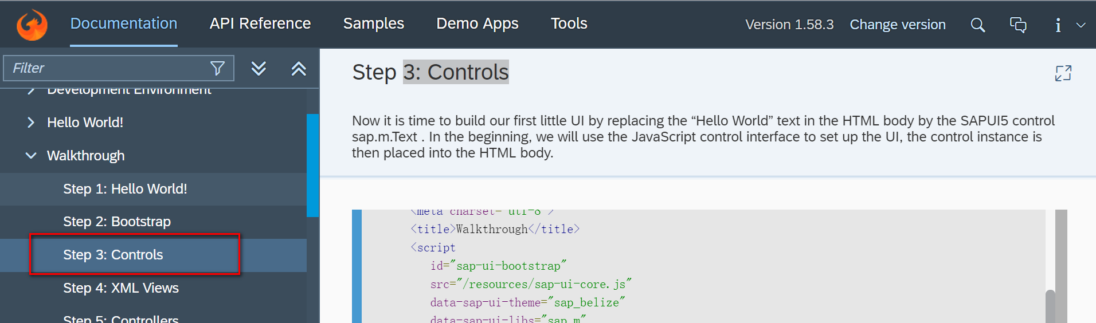

Codes:

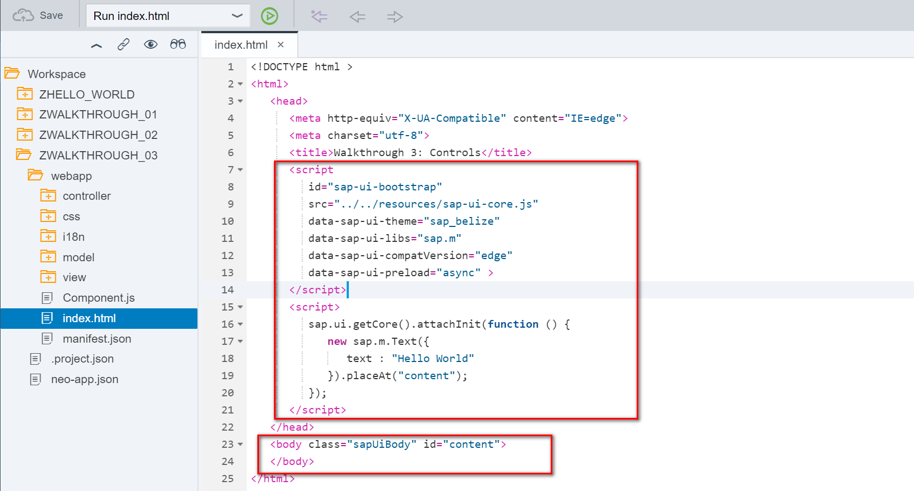

Result:

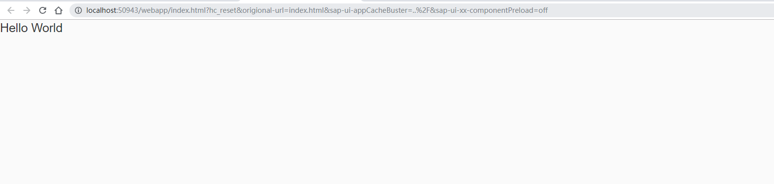

CTRL+SHIFT+ALT+P

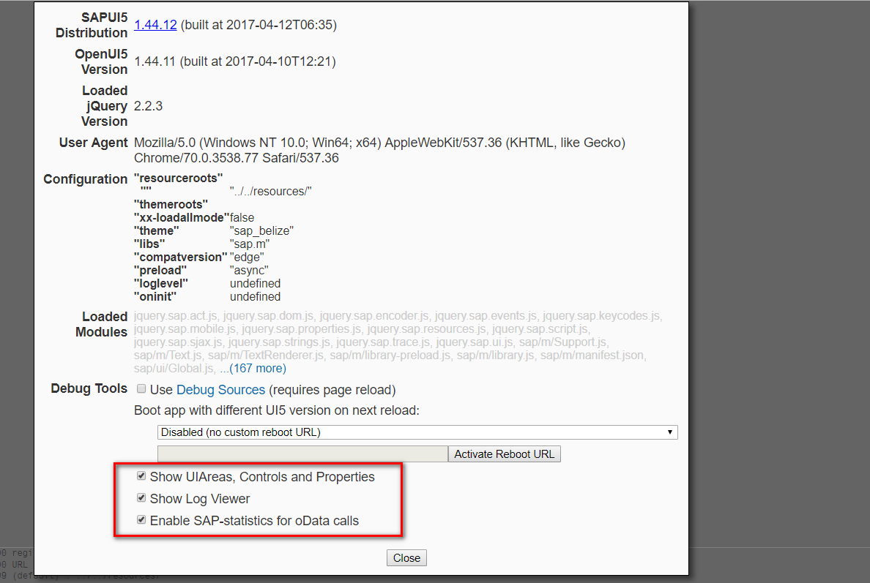

Effect

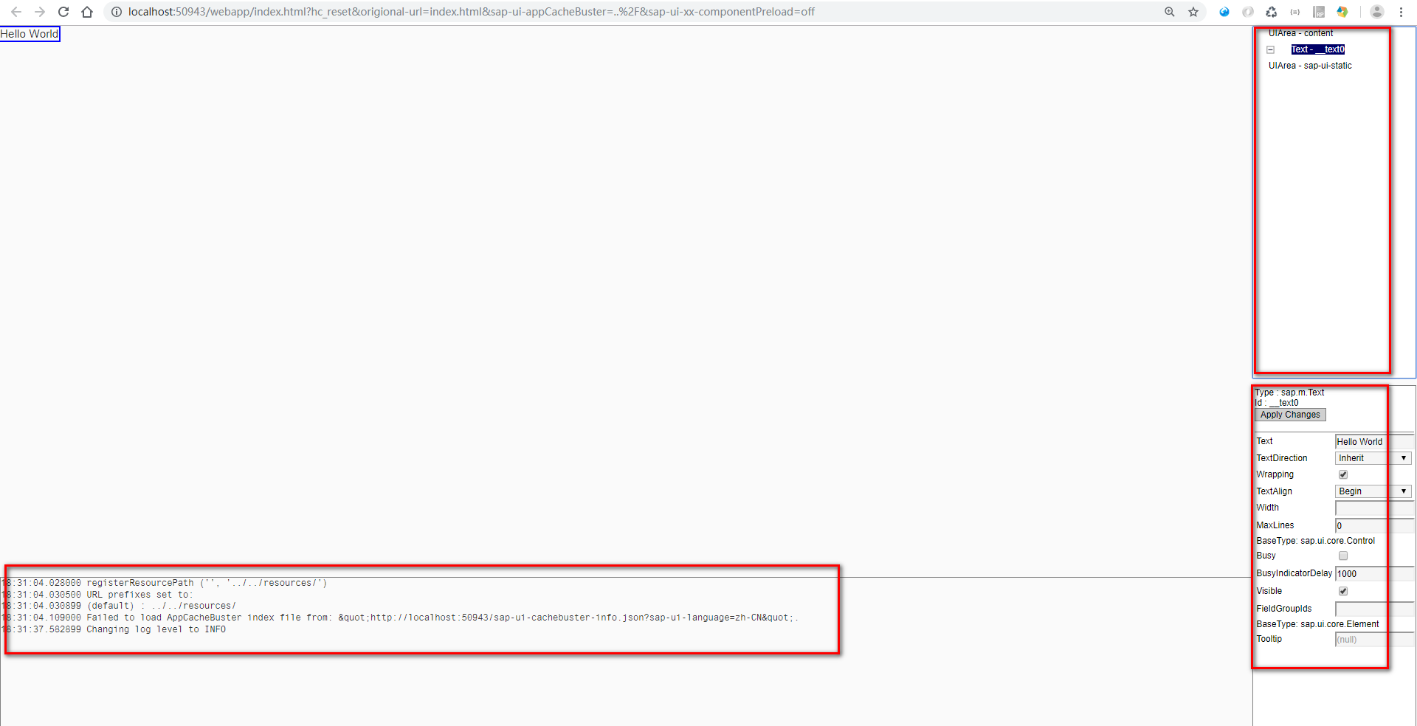

2018/11/01 XiaoMi Beijing Zac,Xie